Chapter 19, Problem 62.

Find the z parameters of the op amp circuit in Fig.19.109. Obtain the transmission parameters.

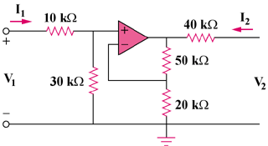

Figure 19.109
For Prob. 19.62.

